10-24-16 Posting Date
CLE-Round Bottom Bridge
PID No. 90440
Clermont County Transportation Improvement District
Response Due Date: 11-10-16

CCTID Project Group No. 11

The Clermont County Transportation Improvement District (CCTID) is requesting Letters of Interest (LOI) from consultants and subconsultants that are currently prequalified with the Ohio Department of Transportation (ODOT) for consultant services for the project listed below. Interested firms may respond in accordance with the LOI requirements specified below.

PID | Project
90440 | Round Bottom Bridge Replacement, C106-4.18

Italicized PID’s have been assigned by the CCTID. Federal/State funding is secured; an ODOT PID will be assigned through the LPA process.

Project Description

Project: ODOT PID TBA
Round Bottom Road Bridge Replacement (C146-4.18) SFN 1359339
Estimated Construction Cost: $2,898,000 (FY 2021 LBR Funding)

This project will involve the replacement of the existing three span concrete box-beam bridge spanning the East Fork of the Little Miami River near the Round Bottom Road intersection with US 50 in Union and Miami Townships, Clermont County, Ohio. Design considerations include the complete replacement of the existing abutment walls and deck and evaluations concerning the rehabilitation of the existing piers, replacement of the existing piers, or other options as feasible. The project also involves the relocation of the existing water main currently attached to the west side of the superstructure and stream gage relocation (north side of the structure). Finally, consideration should be given to the southwest approach near Binning Road to correct existing roadway geometric problems.

ODOT Path 2 Project Development Process (PDP)

NEPA Process: C2

ODOT Prequalification Required:
- Non-complex Roadway Design
- Level 2 Bridge Design
- Right-of-Way Plan Development
- ESA Screening, Phase I ESA and Phase II ESA
- Ecological Surveys and Cultural Resources
- Environmental Document Preparation - CE

Selection Subfactors:
- Experience in Water Main Design and Permitting

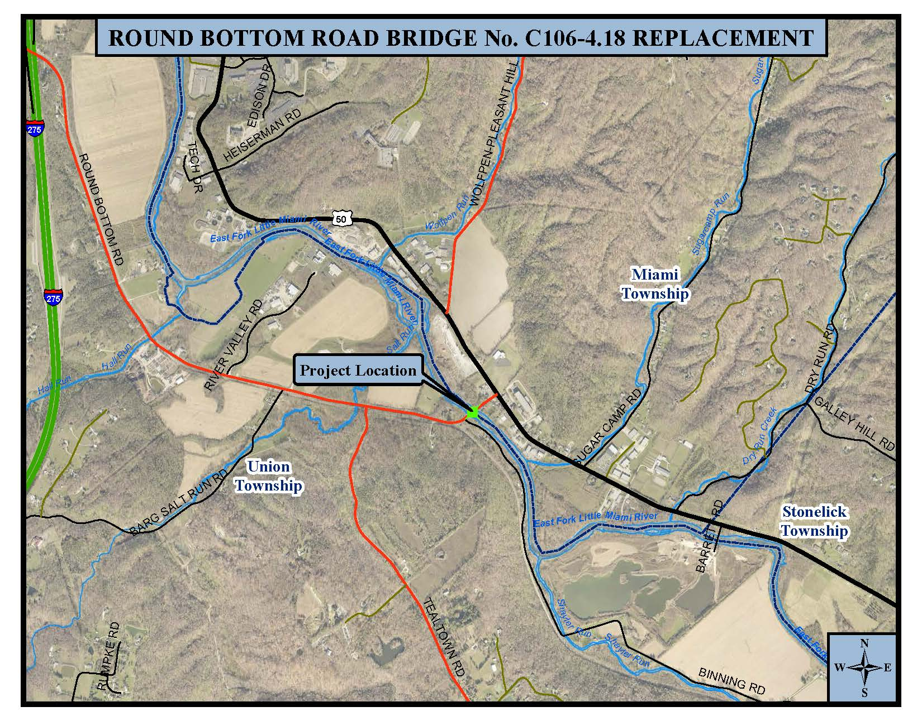

Communications Restrictions

Please note the following policy concerning communication with the CCTID and any Board Members during the announcement and selection process:

During the time period between advertisement and the announcement of final consultant selections, the CCTID will not communicate with consultants (or their agents) regarding the status of the selection process, or entertain any communications related to marketing, etc. When completed, selections will be announced through the CCTID website at:
http://www.goclermont.org/

Permissible communications include project administration activities for authorized agreements, scope and negotiation activities for projects selected but not under contract, training or related activities, and technical or scope of services questions specific to projects posted.

Any questions shall be submitted by e-mail to Craig Stephenson at:
cstephenson@clermontcountyohio.gov.

All questions will be answered in writing and posted to the CCTID website. No notification of responses will be made and interested parties must check the CCTID website for posted responses.

Mailing Instructions and Addresses

Firms interested in being considered for selection should respond by sending the original and three (3) copies of the LOI by 4:00 pm on the response due date listed above:

Pat Manger, CCTID Secretary/Treasurer
2381 Clermont Center Drive
Batavia, OH 45103

LOI received after 4:00 p.m. will not be considered. LOI submitted to any other address will not be considered.

Suspended or Debarred Firms

Firms included on the current Federal list of firms suspended or debarred are not eligible for selection.

Selection Procedures

The CCTID intends to select consultant services for each of the agreements listed above and further described herein based on an enhanced LOI. CCTID may select more than one consultant services firm for task order projects (Surveying Services; Environmental Services; and Real Estate Appraisal & Acquisition Services.). DBE firms are encouraged to submit LOI as prime for task order projects in disciplines where the firm meets prequalification requirements.

The requirements for the LOI and the CCTID Selection Evaluation Rating Form that will be used to select consultants are shown below. Consultants must submit a single LOI for the project(s) for which the consultant is expressing interest. The consultant must visit the site of each project listed. A more defined Scope of Services and Requirements will be supplied to the selected Consultant.

Requirements for LOI, CCTID Selection Process

A. General Instructions for Preparing and Submitting a Letter of Interest

- Provide the information requested in the LOI Content (Item B below), in the same order listed, in a letter signed by an officer of the firm. Do not send additional forms, resumes, brochures, or other material unless otherwise noted in the Project Description.

- LOI shall be limited to ten (10) 8 1/2" x 11" single sided pages plus two (2) pages per project for the combined Key Staff and Project Approach, unless otherwise noted in the Project Description. All pages including the transmittal letter count against the limit.

- Please adhere to the following requirements in preparing and binding LOI:

  - Use a minimum font size of 12-point and maintain margins of 1" on all four sides. All text shall be black type to facilitate machine scanning/copying.
  - Page numbers must be centered at the bottom of each page.
  - Use 8 ½ " x 11" bond paper only. No glossy paper.
  - DO NOT BIND ORIGINAL LOI. Copies should be stapled at the upper left hand corner only. Do not utilize any other binding system.
  - Do not provide tabbed inserts or other features that may interfere with machine scanning/copying.

B. LOI Content shall at a minimum include:

- A list of the Project and PID No. for which the firm is submitting this LOI.

- A brief history of the firm which shall include information pertaining to major areas of expertise and list the types of services for which your firm is currently prequalified by the ODOT.

- A list of representative projects and clients including project costs for contracted projects within the past five (5) years.

- Information relative to insurance coverage of firm which shall include limits and deductions. (Please refer to CCTID Standard Consulting Agreement and Insurance Requirements in C. below)

- Information relative to specialized surveying/engineering equipment, computer hardware and computer software including ArcGIS capabilities. CCTID will use ESRI© ArcGIS 9.1 platform for the maintenance of all mapping files projected in State Plane, Ohio South, NAD83, NAVD88 with map units of U.S. Survey Feet. Mapping files should be capable of being directly loaded or imported into ArcGIS with no translation/transformation/manipulation required by CCTID.

- Provide a description of your Project Approach, not to exceed two pages unless otherwise indicated in the Project Description. Confirm that the firm has visited the site and address your firm’s technical approach, understanding of the project, innovative ideas and any other relevant information concerning your firm’s qualifications for the project.

  - List Project Manager and other key staff members, including key subconsultant staff. Include project engineers for important disciplines and staff members that will be responsible for the work and resumes for key personnel.

  - List significant subconsultants, their current prequalification categories and DBE / EDGE status, and the percentage of work to be performed by each subconsultant.

  - Address the experience of the key staff members on similar projects, and the staff qualifications relative to the selection subfactors noted. For projects that include bridge design (prequalification required in Bridge Design Level 1 or Level 2), address the training and experience of the proposed staff in Load and Resistance Factor Design (LRFD).

  - Describe the capacity of your assigned staff and their ability to perform the work in a timely manner, relative to present workload, and the availability of the assigned staff.

C. Available Documents / Previous Studies:
- CCTID Standard Consulting Agreement and Insurance Requirements
- Existing Bridge Construction Plans from 1976
- CEAO LBR Funding Approval Letter
- Round Bottom Road Water Main Plans
The above documents and related information is available for electronic download through the CCTID website at http://www.goclermont.org/

D. ODOT Project Development Process

All projects will follow the LPA Project Development Process through the ODOT Locally Administered Transportation Projects (LPA) Manual of Procedures for local-let projects, unless otherwise stated in the Project Description. CCTID may utilize Environmental Services; Integrated Traffic Modeling and Simulation; Real Estate Appraisal & Acquisition Services; Geotechnical Services and Surveying Services task order firms in support of the project development for selected project agreements.
E. Consultant Selection Evaluation Rating Form

CCTID

Consultant Selection
Evaluation of Consultant LOI

ODOT/CCTID PID # |  |  | Date:
Project Name:
Name of Consultant:
Name of Evaluator:

Category | Total Value | Scoring Criteria | Score
Management & Team
Project Manager | 15 | See Note 1,2
Strength/Experience of Assigned Staff including Subconsultants | 25 | See Note 3
Firm's Current Workload/ Availability of Personnel | 10 | See Note 4
Consultant's Past Performance | 25 | See Note 5
Project Approach | 25 | See Note 6
Total | 100

Rating Form Scoring Criteria Notes

1) The proposed project manager for each consultant shall be ranked, with the highest ranked project manager receiving the greatest number of points, and lower ranked project managers receiving commensurately lower scores. The rankings and scores should be based on each project manager’s experience on similar projects and past performance. The selection committee may contact ODOT and other outside agencies if necessary. Any subfactors identified should be weighed heavily in the differential scoring.

2) Differential scoring should consider the relative importance of the project manager’s role in the success of a given project. The project manager’s role in a simple project may be less important than for a complex project, and differential scoring should reflect this, with higher differentials assigned to projects that require a larger role for the project manager.

3) The experience and strength of the assigned staff, including subconsultant staff, should be ranked and scored as noted for Number 1 above, with higher differential scores assigned on more difficult projects. Any subfactors identified in the project notification should be weighed heavily in the differential scoring.

As noted above, ODOT and other outside agencies may be contacted.

4) The consultant's workload and availability of qualified personnel, equipment and facilities shall be ranked and scored on a relative, differential scoring type basis. The selection team shall consider an equitable distribution of work to similarly qualified firms.

5) The consultants' past performance on similar projects shall be ranked and scored on a relative, differential scoring type basis, with the highest ranked consultant receiving a commensurately greater number of points. The selection team may consider contacting ODOT and other outside agencies as appropriate to obtain ratings.

6) The differential scoring should consider the complexity of the project and any subfactors identified in the project notification.

